In FortiGate, basic log checking
In FortiGate, basic log checking is an essential skill to monitor network activities, security events, and system health. Here are the steps to perform basic log checking:
1. Log into FortiGate Web GUI
- Open a web browser and enter the IP address of your FortiGate device.
- Log in with your credentials.
2. Navigate to the Logs Section
- In the Web GUI, go to Log & Report.
- Here, you’ll see different log types, including Event Log, Traffic Log, Security Log, System Events, etc.
3. Basic Log Types to Check
- Traffic Log: Shows inbound and outbound traffic. Useful for checking traffic anomalies and network issues.
- Event Log: Records system events such as login attempts, VPN events, and configuration changes.
- Security Log: Tracks security events, including detections of threats like viruses, intrusions, and web filtering actions.
- System Event Log: Logs all system-related events, such as startup, shutdown, and system errors.
4. Filter Logs for Specific Details at Forward Traffic Tab
- Use the Filter option to narrow down logs by criteria like Date/Time, Source, Source Port, Destination, Destination Port, Policy ID, Result.
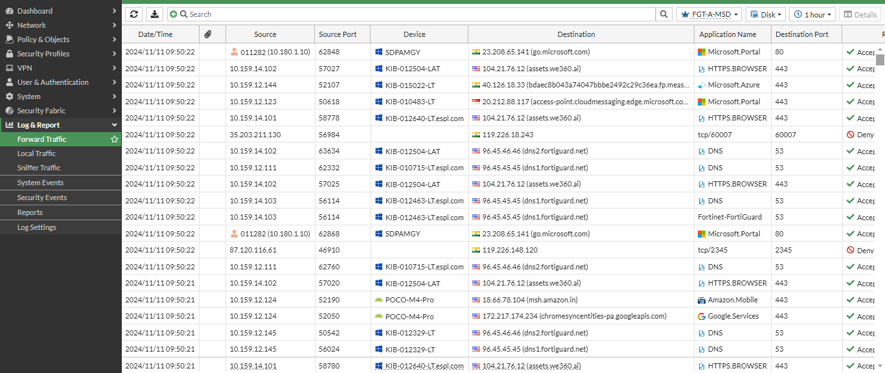
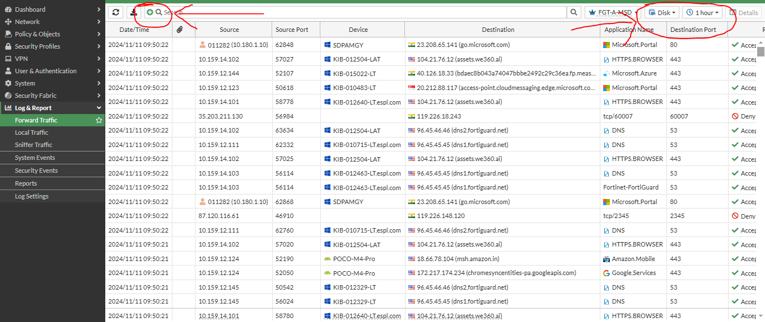
Note: - You can filter from marking tab also.

5. Review System Events Details
- Click on system events log then click on Logs
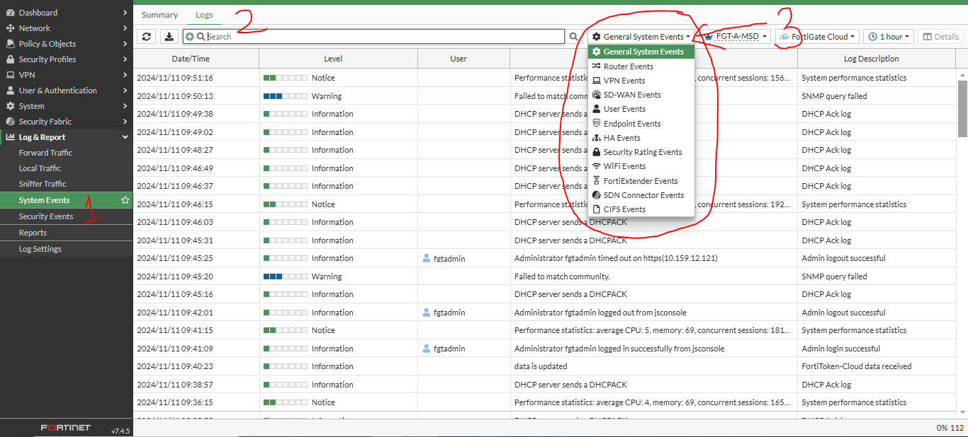
Note: - For System Events you can filter as per your requirement.
6. Export Logs (if needed)
- To analyze logs offline, you can export them by selecting Export to File.
- Choose the preferred file format (e.g., CSV) for viewing in other applications.

7. Command Line Log Checking (CLI)
- If using the CLI, you can access logs with commands like:
  - diagnose log display - Shows logs in real-time.
  - execute log filter category - Sets the log category filter (e.g., traffic, event).
  - execute log display - Displays filtered logs.
- Example: To filter for traffic logs related to a specific IP, use execute log filter addr <IP> before displaying.
8. Setting Up Alerts
- If certain logs need constant monitoring, set up alerts under Log & Report > Alert Email to receive notifications.
9. Advanced Analysis (Optional)
- If you need deeper analysis, consider using FortiAnalyzer or FortiCloud for comprehensive log management and reporting.
Tips
- Regularly monitor critical logs, especially after any policy changes.
- Familiarize yourself with FortiGate’s log severity levels (Information, Warning, Critical) to prioritize log reviews.
These steps will help you keep track of activities and security events on your FortiGate firewall for effective troubleshooting and monitoring.

